BOTBRAINS BATTLE

Real-World Rumble(Round3)

-Mokshyada Mishra

1) INTRODUCTION:

Now a days it is not easy for human beings to go everywhere and find the lost or require things manually, but it is possible automatically without involvement of human species. Hence, its good to remove human intervention from finding the lost or require things like equipment , tools or any other things from different fields, and this can be done by a UAV like autonomous drone etc. So we need to make a UAV fleet that can fly outdoors over a grassy land.

The UAV should be able to take flight autonomously and land in the same way too. It will be required to spot a target amongst a clutter of different objects spread randomly over a grassy land and subsequently communicate the location of the target to their remaining two drones using warm technology. With the help of it army people can find those enemies who illegally crossed boundary of the nation by predefining specification like uniform specification.

1. What do you understand by the Swarm Drones.

ANS:Swarm drones are a group of drones that work together like a team, just like a swarm of bees or a flock of birds. They use something called swarm intelligence, which means they can communicate and coordinate with each other to get tasks done more efficiently than if they were working alone. This technology allows the drones to spread out tasks, cover more ground, and have backup in case something goes wrong. It's pretty cool because it makes the drones more versatile and reliable for different jobs.Features:

* Coordinated Movement: Flying in a synchronized manner to cover more ground.
* Task Division: Distributing tasks among the drones to optimize efficiency.
* Collision Avoidance: Using sensors and algorithms to prevent collisions.
* Communication: Sharing information in real-time to update the swarm on objectives and status.

1. In Done if you want to use ESP8266 with the controller to communicate, how will you do it.

ANS:To use the ESP8266 Wi-Fi module with the drone's flight controller for communication,we can follow the give plan:

1)Hardware Connection:

a) Connecting the ESP8266 to the flight controller using (TX, RX) pins for serial communication.

b). Making sure to connect the Ground (GND) and Power (3.3V) pins as well. Matching the voltage level is a key step.(for ensurance we can use pull down resistor).

2)Firmware Setup:

a) Using the ESP8266 with the appropriate firmware. We can use the custom firmware like NodeMCU or ESP-Open-RTOS for more advanced control.

3)Controller Configuration:

a) Configuring the flight controller firmware (such as ArduPilot or Multifilght) to use the UART port connected to the ESP8266.

b) Setting up the communication parameters, such as baud rate and delay, to match the ESP8266 settings.

4)Programming the ESP8266:

a)Writing a program for the ESP8266 to handle data transmission between the drone and the control station. This includes connecting to WiFi, sending, and receiving messages, and processing the data.

b) Developing a protocol for sending and receiving commands and telemetry data. This might involve using HTTP, or custom protocols for data exchange.

Here is the skeletal code structure written for the reference of judges:

<https://github.com/Mishra-0709/BOTBRAINS-BATTLE-Real-World-Rumble-Round3/blob/main/DroneESP8266.ino>

5)Testing:

a) Conducting simulation tests and followed by field tests to ensure the communication link is stable and the data integrity is maintained.

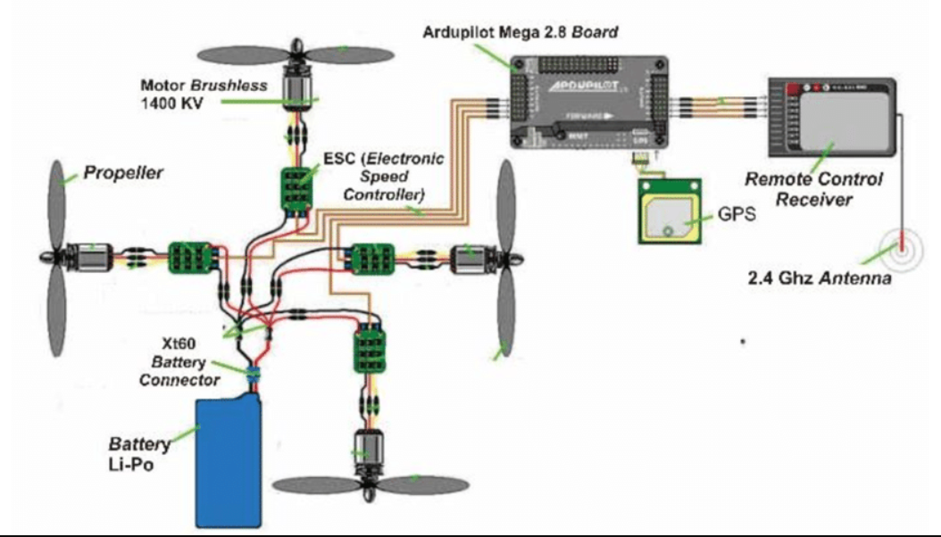

1. If you are allowed to make changes in the design of regular drone what will you change and justify your answer. Also attach the references for the suggested changes in the design.

ANS: Current drone architectures, such as Paparazzi, ICAROUS, and others, typically consist of loosely coupled monolithic boards that limit adaptability and scalability, particularly in meeting the increasing demands for autonomy.Other Limitations are:

1. Limited Battery Life.

2. Payload Capacity: Drones have limited capacity to carry heavy or specialized equipment.

3. Safety Concerns: Drones pose risks such as collisions with other aircraft or obstacles.

4. Data Processing and Communication: Handling and transmitting large amounts of data in real-time poses challenges due to bandwidth limitations and potential latency issues.

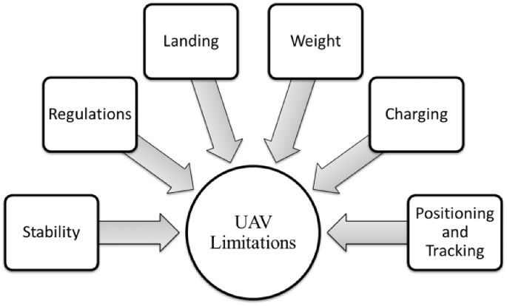

Design Features changes:

drone system concerns into three distinct layers: control, flight management, and planning.

a) **Control Layer**: Manages low-level control modes of the UAV, such as takeoff, landing, and trajectory following, utilizing actuators and sensors for perception tasks.

Features:

• Implements low-level control behaviors like take-off, landing, and cruising.

• Operates with actuators for physical actions and sensors for perception tasks.

• Requires bounded time and space for rapid response and must detect and handle failures.

• Ensures smooth transitions between continuous functions managed by the flight management layer

b) **Flight Management Layer**: Responsible for selecting and executing plans in response to environmental situations fed from the control layer. It directs the UAV to perform tasks like scanning an area or navigating to specific coordinates.

Features:

• Selects and executes plans designed or generated in response to environmental cues.

• Propagates plans from the planning layer to fulfill specific drone missions.

• Orchestrates control behaviors such as flying to a location or scanning an area.

• Uses conditional sequencing to handle varied system states efficiently.

c) **Planning Layer:** Handles high-level planning tasks, including task planning, motion planning, diagnostics, and monitoring of plan executions. It ensures that the drone system can effectively fulfill its mission requirements.

Features: • Generates plans using task planners like TALplanner and TFPOP to achieve high-level missions.

• Constructs plans as task specification trees that sequence actions like scanning an area and delivering supplies.

• Monitors plan execution continuously to detect and recover from failures, ensuring mission success despite unforeseen contingencies.

IDEATION:

The drone architecture idea stemmed from studying the limitations of current designs, which often have rigid structures that limit adaptability and autonomy. Inspired by successful models in mobile robotics, especially the three-layered approach, we can propose a framework dividing drone functions into control, flight management, and planning layers. Each layer plays a crucial role—control for immediate responses and sensor interactions, flight management for dynamic mission handling, and planning for strategic decision-making and long-term goals.

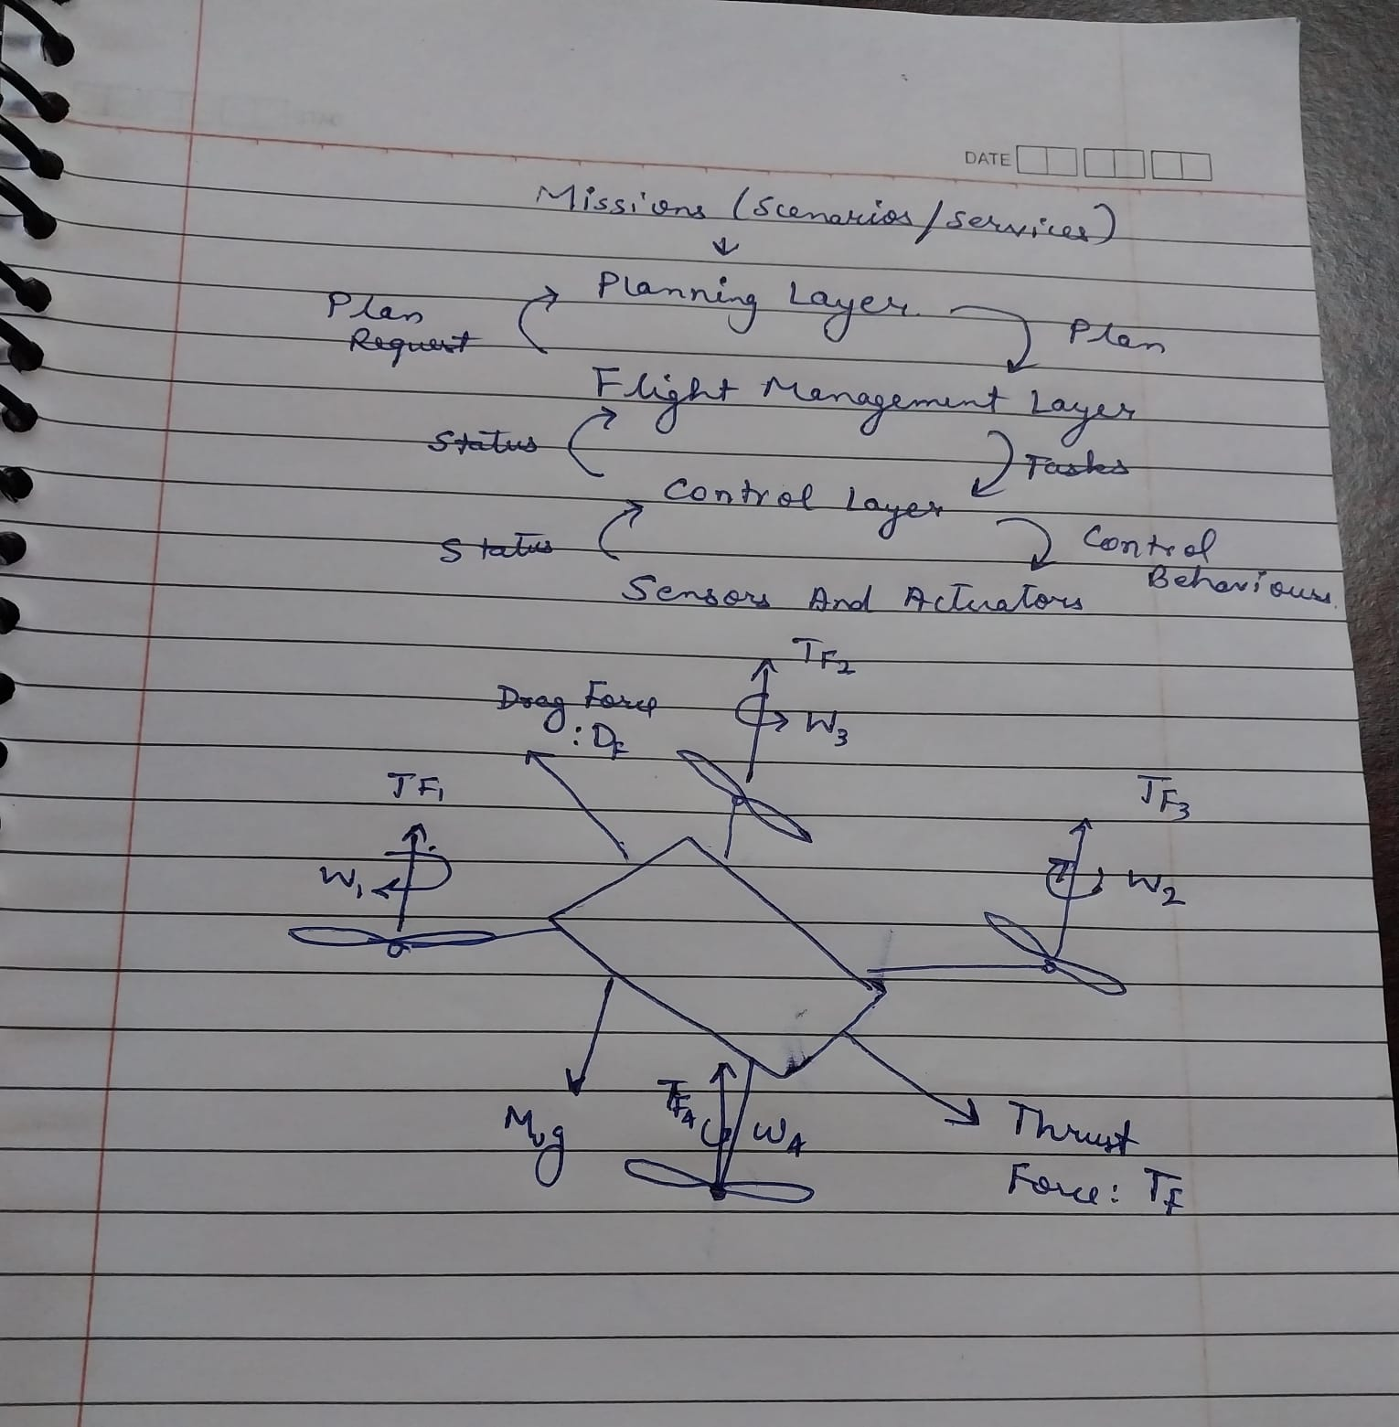

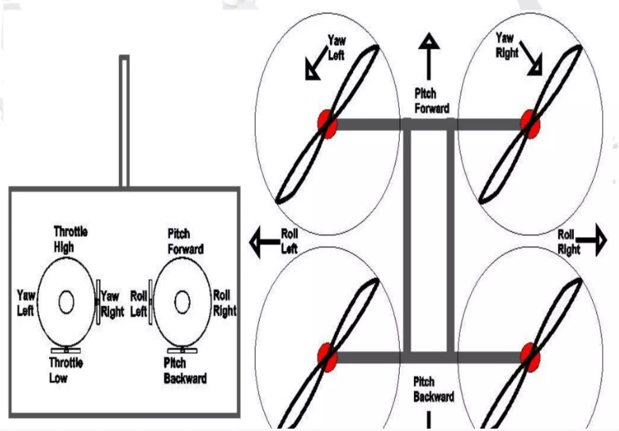

References:1. [(PDF) Towards an Architecture for Customizable Drones (researchgate.net)](https://www.researchgate.net/publication/342003941_Towards_an_Architecture_for_Customizable_Drones)

2. [Circuit-of-Quadcopter-Components.png (850×481) (researchgate.net)](https://www.researchgate.net/publication/336812309/figure/fig5/AS:817944472858628@1572024567661/Circuit-of-Quadcopter-Components.png)